PAR Handling

Overview

Current processing
This is a new functionality.

New requirement
- All PAR functionality for linkage must be removed
  - Until new Options Linkage Plan is rolled out for all classes, for orders that end up on PAR, PAR must be able to determine if the order is eligible for old linkage or New Options Linkage
  - The ‘New Options Linkage Flag’ must be used as part of the evaluation
- For orders that have ended up on PAR, if the Book button or Auto-Book is used then CBOEdirect must evaluate the order (i.e. New HAL or SAL as applicable) and determine if the order needs to be linked away
- The functionality relating to T/A, Auto T/A, and T/B buttons must remain unchanged
- There must be a new button for the Sweep and Return (S/R) feature required on PAR
  - S/R button must be available to PAR users as well and not just CBOE PAR officials but based on the enablement/profile for that user
  - For orders that have ended up on PAR, if the S/R (Sweep and Return) button is used then CBOEdirect must
    - skip the auction process (i.e. both New HAL and SAL)
    - determine if the order needs to be linked away
    - sweep CBOE and the Away Exchanges
    - return the remainder to the originating PAR
  - While sending a S/R request the PAR user must be able to specify the S/R Price (i.e. can be different from the order price but only SAME or BETTER than it) and S/R Quantity (i.e. can be different from the order quantity but only SAME or LESS than it) to be swept
  - The S/R request must not be allowed to submit with a volume that is less than the initially suggested default S/R Volume
  - The default S/R Price and S/R Volume in the S/R request must be determined as follows
    - For a Limit Order, the default S/R Price must be the order price until it crosses the Best Customer Book Price and then on it must be the Best Customer Book Price
    - For a MKT Order, the default S/R Price must be the Best Customer Book Price
    - For a Limit or MKT Order, the default S/R Volume for the calculated default S/R price must be the volumes of all the prices that are BETTER at the Away Exchanges and/or CBOE Quote/Non-Customer-likes in addition to the Customer volume, if any at that price

 | CBOE Market/ Montage
 | CBOE  5 @ 1.04 | ISE  10 @ 1.05 | NYSE  15 @ 1.07 | CBOE  20 @ 1.08 | CBOE  25 @ 1.09  PHLX  50 @ 1.09 | CBOE  100 @ 1.10
 | Non-Customer |  |  | Non-Customer | Customer
BUY 1000 @ 1.03 | S/R Default Price = 1.03  S/R Default Volume = 0
BUY 1000 @ 1.04 | S/R Default Price = 1.04  S/R Default Volume = 0
BUY 1000 @ 1.05 | S/R Default Price = 1.05  S/R Default Volume = 5
BUY 1000 @ 1.06 | S/R Default Price = 1.06  S/R Default Volume = 15 (5 + 10)
BUY 1000 @ 1.07 | S/R Default Price = 1.07  S/R Default Volume = 15 (5 + 10)
BUY 1000 @ 1.08 | S/R Default Price = 1.08  S/R Default Volume = 30 (5 + 10 + 15)
BUY 1000 @ 1.09 | S/R Default Price = 1.09  S/R Default Volume = 55 (5 + 10 + 15 + 25)
BUY 1000 @ 1.10 | S/R Default Price = 1.09  S/R Default Volume = 55 (5 + 10 + 15 + 25)
BUY 1000 @ 1.11 | S/R Default Price = 1.09  S/R Default Volume = 55 (5 + 10 + 15 + 25)
BUY 1000 @ MKT | S/R Default Price = 1.09  S/R Default Volume = 55 (5 + 10 + 15 + 25)

 | CBOE Market/ Montage
 | CBOE  5 @ 1.04 | ISE  10 @ 1.05 | NYSE  15 @ 1.07 | CBOE  20 @ 1.08 | CBOE  25 @ 1.09  PHLX  50 @ 1.09 | CBOE  100 @ 1.10
 | Customer |  |  | Non-Customer | Customer
BUY 1000 @ 1.03 | S/R Default Price = 1.03  S/R Default Volume = 0
BUY 1000 @ 1.04 | S/R Default Price = 1.04  S/R Default Volume = 5
BUY 1000 @ 1.05 | S/R Default Price = 1.04  S/R Default Volume = 5
BUY 1000 @ 1.06 | S/R Default Price = 1.04  S/R Default Volume = 5
BUY 1000 @ 1.07 | S/R Default Price = 1.04  S/R Default Volume = 5
BUY 1000 @ 1.08 | S/R Default Price = 1.04  S/R Default Volume = 5
BUY 1000 @ 1.09 | S/R Default Price = 1.04  S/R Default Volume = 5
BUY 1000 @ 1.10 | S/R Default Price = 1.04  S/R Default Volume = 5
BUY 1000 @ 1.11 | S/R Default Price = 1.04  S/R Default Volume = 5
BUY 1000 @ MKT | S/R Default Price = 1.04  S/R Default Volume = 5

 | CBOE Market/ Montage
 |  | ISE  10 @ 1.05 | NYSE  15 @ 1.07 | CBOE  20 @ 1.08 | CBOE  25 @ 1.09  PHLX  50 @ 1.09 | CBOE  100 @ 1.10
 |  |  |  | Non-Customer | Customer
BUY 1000 @ 1.03 | S/R Default Price = 1.03  S/R Default Volume = 0
BUY 1000 @ 1.05 | S/R Default Price = 1.05  S/R Default Volume = 0
BUY 1000 @ 1.06 | S/R Default Price = 1.06  S/R Default Volume = 10
BUY 1000 @ 1.07 | S/R Default Price = 1.07  S/R Default Volume = 10
BUY 1000 @ 1.08 | S/R Default Price = 1.08  S/R Default Volume = 25 (10 + 15)
BUY 1000 @ 1.09 | S/R Default Price = 1.09  S/R Default Volume = 70 (10 + 15 + 20 + 25)
BUY 1000 @ 1.10 | S/R Default Price = 1.09  S/R Default Volume = 70 (10 + 15 + 20 + 25)
BUY 1000 @ 1.11 | S/R Default Price = 1.09  S/R Default Volume = 70 (10 + 15 + 20 + 25)
BUY 1000 @ MKT | S/R Default Price = 1.09  S/R Default Volume = 70 (10 + 15 + 20 + 25)
BUY 50 @ 1.10 | S/R Default Price = 1.09  S/R Default Volume = 50 (10 + 15 + 20 + 5)

  - CBOEdirect must sweep and send outbound linkage orders only up to the price and up to the quantity specified in the S/R request
  - While doing linkage for S/R request, to an Away Exchange, CBOEdirect must link away only ONCE and not make any further repeated outbound linkage attempts for quantity that has been REJECTED/CANCELLED
  - If there is quantity remaining from the S/R request that cannot either be traded in CBOE or Linked Away then that remaining quantity must be kept ON-HOLD
    - Any rejects or cancels that are received from the Away Exchanges must immediately increment the ON-HOLD quantity by the amount that was rejected or cancelled and continue to HOLD
    - For details on handling of ON-HOLD quantity
    - Before returning the remainder to PAR, the total quantity ON-HOLD must be re-evaluated for possible trading with CBOE market if CBOE is the NBBO and if CBOE is not the NBBO then that remaining quantity must be returned back to the originating PAR
  - All trades (i.e. both internal and linkage) done for a S/R request must be marked so in the Order History table to indicate that the trade was because of a S/R request
- Billing must be able to identify linkage orders that have been generated because of Book or Auto-Book or S/R requests. Order History table must be populated with details like PAR LoginId, PAR Work Station Number and acronym of the Executing PAR Broker.

Assumption

For detail please refer to Requirement document.

Implementation
IDL Changes:
- /cmi/idl/cmiConstants.idl
Add new Constant to interface ActivityTypes
const cmiTraderActivity::ActivityType MANUAL_ORDER_SR = 718;
const cmiTraderActivity::ActivityType MANUAL_ORDER_SR_TIMEOUT= 719;
const cmiTraderActivity::ActivityType MANUAL_ORDER_SR_TIMEOUT_FAILURE=816;

- /domain/idl/constants.idl
- Add new constant to
  - interface TradingRestrictions
    - const order::TradingRestriction SWEEP_AND_RETURN = 3;
  - interface OHSRoutingReasons
    - const MANUAL_REROUTE_ORDER_SR = 42;

The classes that will be changed for this functionality are:
- com.cboe.server.workflow.Enums
  - Modify enum RequestTypeEnum
    - Add MANUAL_ORDER_SR to enum
- com.cboe.ohs.domain.interfaces.OHSRoutingReason
  - Modify enum OHSRoutingReason
    - Add enum for MANUAL_REROUTE_ORDER_SR
- com.cboe.ohs.receivers.oms.ManualOrderMaintenanceServiceDelegateImpl

  - Modify method public void acceptManualOrderReturn(ManualMarketBrokerDataStruct marketData,OrderRoutingParameterStruct p_orderRouting, OrderIdStruct p_orderID, String p_sessionName, int p_productKey, OrderHandlingInstructionStruct p_orderHandling, int[] legMaxExecutionVolumes, long p_requestTimet, short activityType)
    - Add case to switch in section if (p_legEntryDetails == null) section for Activity type MANUAL_ORDER_SR.
  - Modify method private RequestTypeEnum getRequestType(short p_activityType)
    - Add case for Activity type MANUAL_ORDER_SR
  - Modify method private void executeTimeoutWithInstructions(OrderRoutingParameterStruct p_orderRouting, Order p_order, int p_quantity, int[] p_legQuantitites, OrderHandlingInstructionStruct p_orderHandling, short p_activityType, long p_activityTime, ManualMarketBrokerDataStruct p_marketData, ManualFillStruct[] p_manualFillStruct, int p_transactionSequenceNumber, String methodName)
    - Add activity type MANUAL_ORDER_SR_TIMEOUT
  - Modify method private boolean isOrderTimeout(short p_activityType)
    - Add activity type MANUAL_ORDER_SR_TIMEOUT

- com.cboe.domain.util.ManualActivityHelper –
  - Modify method public static String getManualRouteDescription(short p_activityType) to set the route description.
    - Add case to switch for Activity type MANUAL_ORDER_SR_TIMEOUT

- com.cboe.ohs.domain.interfaces.OrderHistoryHome –
  - Add method public void createHistoryManualOrderSR(Order theOrder, Price toBeTradedPrice, int toBeTradedQty, int qtyRouted, OrderHistoryCommonInfo orderHistoryCommonInfo);

- com.cboe.ohs.domain.OrderHistoryHomeImpl
  - Add method implementation public void createHistoryManualOrderSR(Order theOrder, Price toBeTradedPrice, int toBeTradedQty, int qtyRouted, OrderHistoryCommonInfo orderHistoryCommonInfo)

- com.cboe.ohs.domain.OrderHistoryImpl
  - Modify Constructor public OrderHistoryImpl(Order order, short eventType, boolean bypassReflection,HistoryServiceIdGenerator idGenerator, OrderHistoryCommonInfo orderHistoryCommonInfo,AuctionHistoryStruct auctionHistory)
    - Add case for Activity type MANUAL_ORDER_SR_TIMEOUT to set the executive Broker;

- com.cboe.ohs.workflow.steps.WFStepPersistOrderRerouteHistory
  - Modify method public Enum execute(OrderContext p_context)
    - Add case for Activity type MANUAL_ORDER_SR and call the method createHistoryManualOrderSR(Order theOrder, Price toBeTradedPrice, int toBeTradedQty, int qtyRouted, OrderHistoryCommonInfo orderHistoryCommonInfo) of com.cboe.ohs.domain.OrderHistoryHomeImpl.

- com.cboe.ohs.workflow.steps.WFStepManualRouteDetail
  - Modify method public Enum execute(OrderContext p_context) throws Exception
    - Add case for Activity type MANUAL_ORDER_SR and set the route reason and route description in the workflow context.

- com.cboe.ohs.workflow.steps.WFStepSendToRoute
  - Modify method protected void createOrderHistory(BaseOHSContext p_context, short activityType, String source, short sourceType)
    - Add case for ActivityTypes.MANUAL_ORDER_SR_TIMEOUT and ActivityTypes.MANUAL_ORDER_SR_TIMEOUT_FAILURE

- com.cboe.ohs.workflow.steps.WFStepSetPARHandlingInstruction
  - Modify method protected PriceStruct getSimpleBOTR(OrderContext p_context, QuoteQueryV2Struct quoteQueryV2)
    - Set the botr price to No_PriceStruct for ActivityTypes.MANUAL_ORDER_SR

- com.cboe.ohs.workflow.steps.electronic.WFStepElectronicSendToRoute
  - Modify Method createOrderHistory(BaseOHSContext p_context, short activityType, String source, short sourceType)
    - Add case for Activity type MANUAL_ORDER_SR_TIMEOUT and MANUAL_ORDER_SR_TIMEOUT_FAILURE

- com.cboe.ohs.interfaces.workflow.ManualTimeoutContext
  - Modify method public ActionEnum getId()
    - Add case for ActivityTypes.MANUAL_ORDER_SR_TIMEOUT

- com.cboe.ohs.workflow.steps.WFStepRethrowException
  - Modify method public Enum execute(BaseOHSContext p_context) for Activity type MANUAL_ORDER_SR

- com.cboe.businessServices.orderRoutingDestination.OrderValidationOpenOutcryStrategy
  - Add method validateSweepAndReturnForNewHAL(OrderHandlingStruct order, TradingProduct aTradingProduct) throws DataValidationException
    - If New HAL is disabled then this method will throw DataValidationException
  - Modify Method validateOrder(OrderHandlingStruct order, boolean allowZero, boolean isToValidteHandlingInstruction)
    - Call method validateSweepAndReturnForNewHAL.

- com.cboe.businessServices.orderRoutingDestination.OrderImpl
  - Modify method getRemainingQuantityForTrade()
    - If TradingRestriction is S/R return the remaining quantity as Total quantity allowed minus shipped quantity.

- com.cboe.businessServices.brokerService.BrokerHybridLimitOrderStrategy
  - Modify method protected void doPostprocess(Order anOrder, OrderBook book, Broker broker)
    - Check if the Trading Restriction is Sweep and Return
      - If any quantity is shipped away simply return from the method.

- com.cboe.businessServices.brokerService.BrokerProcessorHybrid2Impl
  - Override method public void doNormalOrderProcessing(Order anOrder)
    - Get the TradingRestriction value from anOrder.
    - If TradingRestriction == TradingRestrictions.SWEEP_AND_RETURN.
      - Call method doTradeAndSweepOrderProcessing method
    - Else
      - Call super.doNormalOrderProcessing(Order anOrder)
  - Modify method doTradeAndSweepOrderProcessing(Tradable incomingTradable, List<Order> auctionResponses, Order anOrder, OrderBook orderBook, boolean isOrderFlashed)
    - If TradingRestriction == TradingRestrictions.SWEEP_AND_RETURN
      - Set the execution price as tradeEndingPrice for Autolink Enable and disabled cases.
  - Modify method handleSweepRemainder(Order anOrder, OrderBook orderBook, boolean bookOrder, int remainingQuantity)
    - As we don’t want to book or cancel the remainder we will simply return from the method.

Scripts
- None

Database
- None

SetContext

XML/DTD
- /ohs/properties/xml/ReroutedOrderExecutorHome.xml
  - Add MANUAL_ORDER_SR to ReRoutedOrderConfiguration reThrowExceptionForTENotAvailable and reThrowExceptionToPAR

Homes/Services

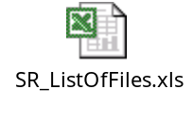

ImplPlan
- Sequence Diagram( S/R flow in OHS)
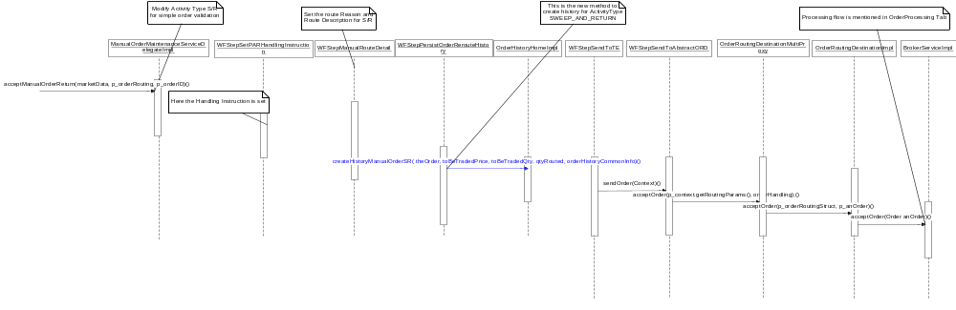

S/R Request Order Processing
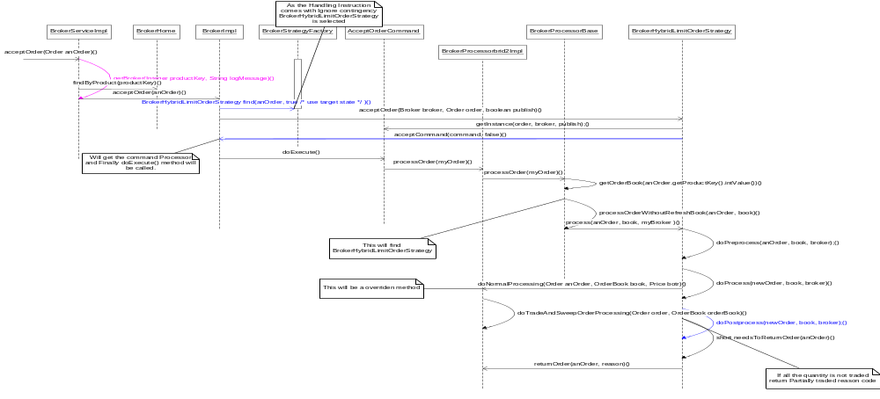

S/R Timeout and Timeout Failure

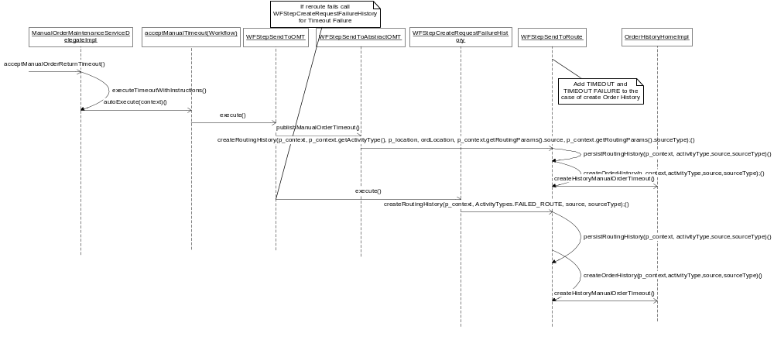

PerformanceTestingProcedure
- .

TestingProcedure

OperatorProcedure
- .

Fallback/Failover

